20/12/2016

Olti Asllanaj

Intro To Database

**Hospital Management System E/R diagram!**

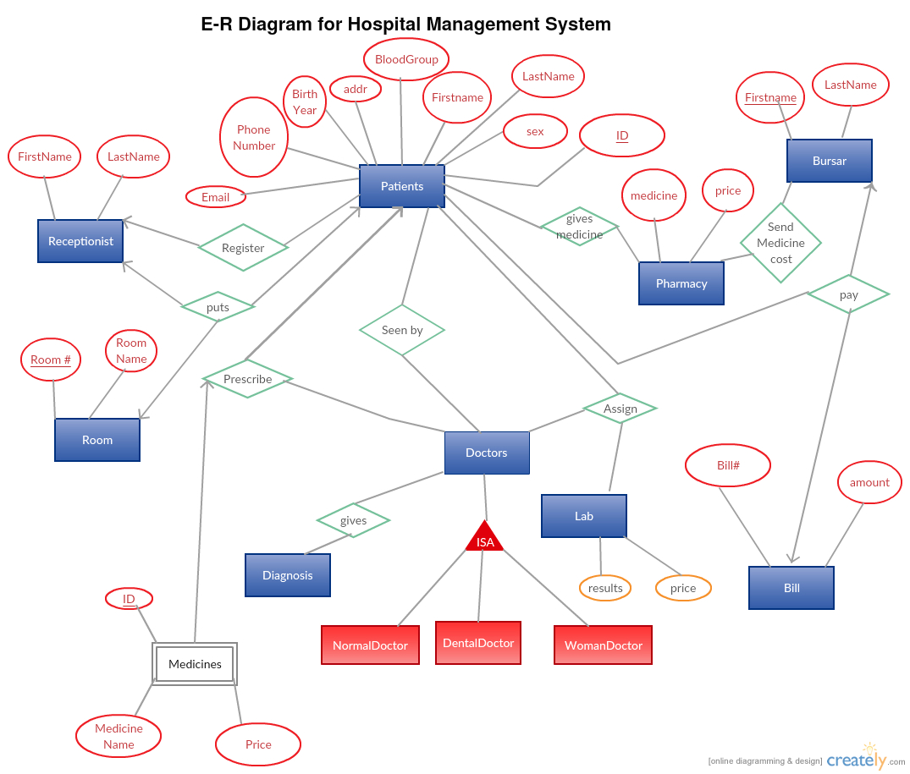

To create this diagram I used creately. You need to signed in and you can use their website for free to create E/R diagrams.

<https://creately.com/>

In this E/R diagram I have used **one to one relationship**, **many to one**, **many to many**, **subclass**, **weak entity set**.

The doctor has three subclasses: NormalDoctor, DentalDoctor,WomanDoctor.

The doctor attends the patient.

The doctor gives the diagnosis. The doctor can assign the patient to the lab for lab tests and scans. The doctor can prescribe medicines to the patient.

The receptionist keeps truck of all the patient informations. The receptionist can register new patients. Can send the patients to the relevant doctor and can assign the room to new patients or update the room for old patients.

The pharmacy can give the medicine to the patients and also can calculate the price and send that price to the Bursar so the patient can pay.

The relations are:

1. Users(username,password,fname,sname,type)
2. Rooms(Room_no, Room_name, patientinroom)
3. Medicines(id, medicine_name, price)
4. Patients(id, fname, sname, email, address, phone, sex, Bloodgroup, birthyear)
5. Medications(id, patient_id, status, symptoms, tests, Test_result, medical, Doctor_type, Doctor_price, Test_price, medical_price, date, month, year)

FD’s for relation User are:

username -> password

username -> fname

username -> sname

username -> type

So username is a key because this attribute determines all the other attributes of the relation.

FD’s for relation Room are:

Room_no -> Room_name

Room_no -> patientinroom

So Room_no is a key because this attribute determines all the other attributes of the relation.

FD’s for relation Medicine are:

id -> medicine_name

id -> price

So id is a key because attribute determines all the other attributes of the relation.

FD’s for relation Patients are:

id -> fname

id -> sname

id -> email

id -> address

id -> phone

id -> sex

id -> Bloodgroup

id -> birthyear

So id is a key because this attribute determines all the other attributes of the relation.

FD’s for relation Medications are:

id -> patient_id

id -> status

id -> symptoms

id -> test

id -> Test_results

id -> medical

id -> Doctor_type

id -> Doctor_price

id -> Test_price

id -> medical_price

id -> date

id -> month

id -> year

So id is the key because this attribute determines all the other attributes of the relation.

USER TABLE

|  |  |  |  |  |  |
| --- | --- | --- | --- | --- | --- |
|  | username | password | fname | sname | type |
| 1 | Admin | 1234 | Olti | Asllanaj | Admin |
| 2 | Reception | 1234 | Diana | Portillo | Reception |
| 3 | Doctor | 1234 | Alba | Shkurti | Doctor |
| 4 | DentalDoctor | 1234 | Andi | Rama | DentalDoctor |
| 5 | NormalDoctor | 1234 | Julian | Jackson | NormalDoctor |
| 6 | WomanDoctor | 1234 | Joana | Pellumbi | WomanDoctor |
| 7 | Laboratory | 1234 | Akim | Gjata | Laboratory |
| 8 | Pharmacy | 1234 | Romina | Asllanaj | Pharmacy |
| 9 | Bursar | 1234 | Silva | Kaziu | Bursar |
| 10 | Doctor | 1234 | Beni | Asllanaj | Doctor |

ROOM TABLE

|  |  |  |  |
| --- | --- | --- | --- |
|  | Room_no | Room_name | patientinroom |
| 1 | 125 | Olti | 1 |
| 2 | 67 | John | 1 |
| 3 | 56 | Cristal | 2 |
| 4 | 34 | Lara | 1 |
| 5 | 100 | Xhoi | 3 |
| 6 | 23 | Miri | 1 |
| 7 | 49 | Besiana | 1 |
| 8 | 30 | Lola | 2 |
| 9 | 15 | Endri | 1 |
| 10 | 2 | John | 1 |

MEDICINE TABLE

|  |  |  |  |
| --- | --- | --- | --- |
|  | id | medicine_name | price |
| 1 | 786 | paracetamol | 50 |
| 2 | 121 | Vitamin D | 8 |
| 3 | 45 | Advil | 14 |
| 4 | 3462 | Amoxicillin | 120 |
| 5 | 90 | * ibuprofen | 42 |
| 6 | 24 | * Fish Oil | 12 |
| 7 | 13 | Vitamin A | 18 |
| 8 | 03 | Oki | 10 |
| 9 | 08 | Amistar | 200 |
| 10 | 456 | Amicip | 86 |

PATIENT TABLE

|  |  |  |  |  |  |  |  |  |  |
| --- | --- | --- | --- | --- | --- | --- | --- | --- | --- |
|  | id | fname | sname | email | address | phone | sex | Bloodgroup | birthyear |
| 1 | 1 | Olti | Asllanaj | Oltias1987@gmail.com | Boston | 123456 | Male | O | 1987 |
| 2 | 3 | Bledi | Asllanaj | bledi@yahoo.com | Danvers | 342567 | Male | Ab | 1989 |
| 3 | 4 | Joana | Pellumbi | joana@hotmail.com | Italy | 98234 | Female | B | 1989 |
| 4 | 7 | Xhino | Gallo | Xhino1987@gmail.com | Boston | 598330 | Male | A | 1988 |
| 5 | 5 | Alba | Shkurti | Shkurti.@gmail.com | Boston | 9780345 | Female | O | 1986 |
| 6 | 6 | Summit | Agrival | Summit@gmail.com | India | 764934 | Male | B | 1990 |
| 7 | 9 | Asha | Deka | Asha@gmail.com | Boston | 546723 | Female | O | 1989 |
| 8 | 2 | John | Baptista | John_1985@gmail.com | New York | 6530123 | Male | AB | 1985 |
| 9 | 9 | Astrit | Asllanaj | Astrit@hotmail.com | Boston | 978546 | Male | O | 1964 |
| 10 | 10 | Erka | Pellumbi | Erka@gmail.com | New York | 764938 | Female | A | 1966 |

MEDICATION TABLE

|  |  |  |  |  |  |  |  |  |  |
| --- | --- | --- | --- | --- | --- | --- | --- | --- | --- |
|  | 1 | 2 | 3 | 4 | 5 | 6 | 7 | 8 | 9 |
| id | 1 | 2 | 3 | 4 | 5 | 6 | 7 | 8 | 9 |
| patient  _id | 1 | 2 | 5 | 6 | 4 | 9 | 8 | 5 | 7 |
| status | finish | finish | finish | lab | lab | lab | lab | recdoctor | recdoctor |
| symptoms | headache | Brain  damage | cancer | infect | Eye  infect | Ear  pain | Feet  pain | Tooth  pain | Preganacy  test |
| tests | X-RAY | MIR | Blood test | Blood  test | Read  alphabet | Ear tests | massage | touch | Scan |
| Test_  results | Negative | Positive | Negative | Positive | positive | good | good | clean | Baby is  good |
| medical | Advil | antibiotics | nothing | antibiotic | glasses | antibiotic | nothing | antibitic | iron |
| Doctor_  type | NormalDoctor | NormalDoctor | NormalDoctor | NormalDoctor | NormalDoctor | NormalDoctor | NormalDoctor | Dental  Doctor | Woman  Doctor |
| Doctor_  price | 1000 | 2000 | 150 | 400 | 200 | 100 | 56 | 500 | 100 |
| Test_  price | 200 | 199 | 436 | 234 | 50 | 123 | 100 | 1300 | 400 |
| Medical_  price | 345 | 234 | 664 | 421 | 876 | 1234 | 564 | 123 | 103 |
| date | 15 | 23 | 11 | 22 | 10 | 07 | 05 | 14 | 18 |
| month | 02 | 04 | 10 | 11 | 12 | 05 | 03 | 06 | 09 |
| year | 2016 | 2016 | 2016 | 2016 | 2016 | 2016 | 2016 | 2016 | 2015 |

**USER INTERFACE**

The requirement of this assignment is to create a user interface, which cooperates with the database to access the Hospital Management System.

For user interface, I have choosen to use PHP, HTML && CSS for the Front End and SQL for Back End.

**HOW THE SYSTEM WORKS**

1. Patient comes to the hospital and talks to the Receptionist.

2. The receptionist asks about the patient’s details e.g. Name, last name, email, phone number, address, gender, blood group, birth year. After taking all the patient information and stored in the system , the receptionist assigns the patient to the relevant doctor and gives the doctor all the patient information.

3. The patient meets with the doctor, and he/she asks about what problems or symptoms the patient has or is suffering from. After, the doctor visits the patient and listens to him about the symptoms, he assigns the patient to the lab for further tests.

4. The laboratories’ will receive all the patient’s information from the doctor and start the tests and scans that will determine the condition of the disease and why the patient has this type of symptoms. After the tests are done and the lab knows the results, they will send the result back to the doctor.

5. When the tests comes and the doctor knows the condition (‘s) of the patient he prescribes medicine for the patients and sends him to the pharmacy.

6. The Pharmacist starts to prepare the medicine that the patient needs to be healthy. When the patient comes in the pharmacy the pharmacist calculates the price and send the patient to the bursar so he can pay.

7. The Bursar asks for the payment and than the patient can go home.

**Username**  **Password**

Admin 1234

Reception 1234  
Doctor 1234

DentalDoctor 1234  
NormalDoctor 1234  
WomenDoctor 1234  
Laboratory 1234

Pharmacy 1234  
Bursar 1234

**LOGGING IN**

I created this interface for the Administrator or Admin to Log in to the system. The Admin is responsible for creating other users for different departments. For example: Doctors, receptionist, pharmacist, bursar, and laboratories. When the user enters the username and passwords and after clicking the login in button it takes the user to the index page if the credentials are correct.

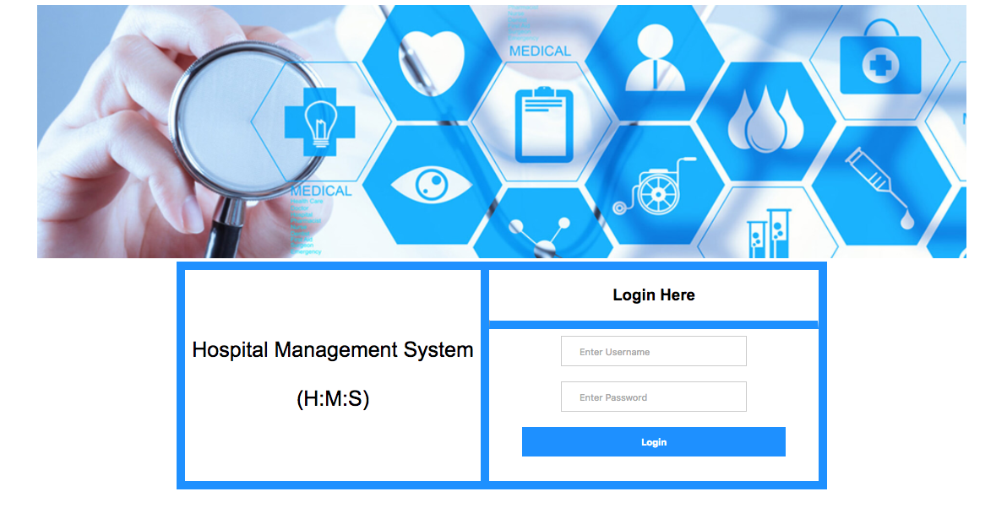

**ADMINISTRATOR FUNCTIONS**

The administrator is responsible for adding users, adding rooms, and updating. The users referred here are receptionist, Doctor, Pharmacist, Lab, Bursar, Admins, and Bursar.

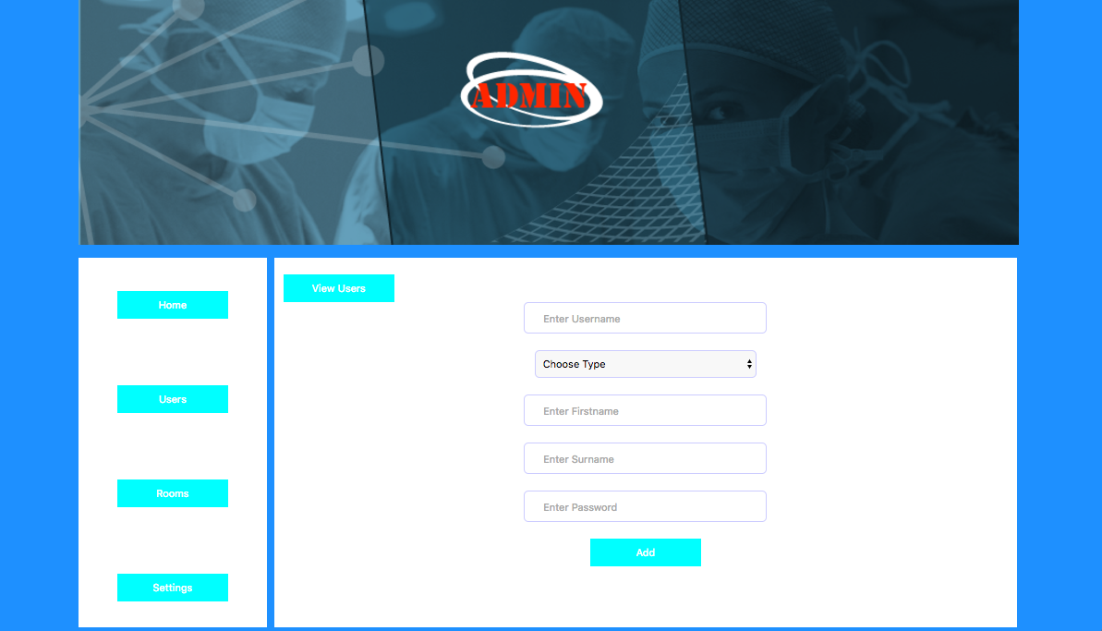

You can ADD the room by pressing the button Add Room

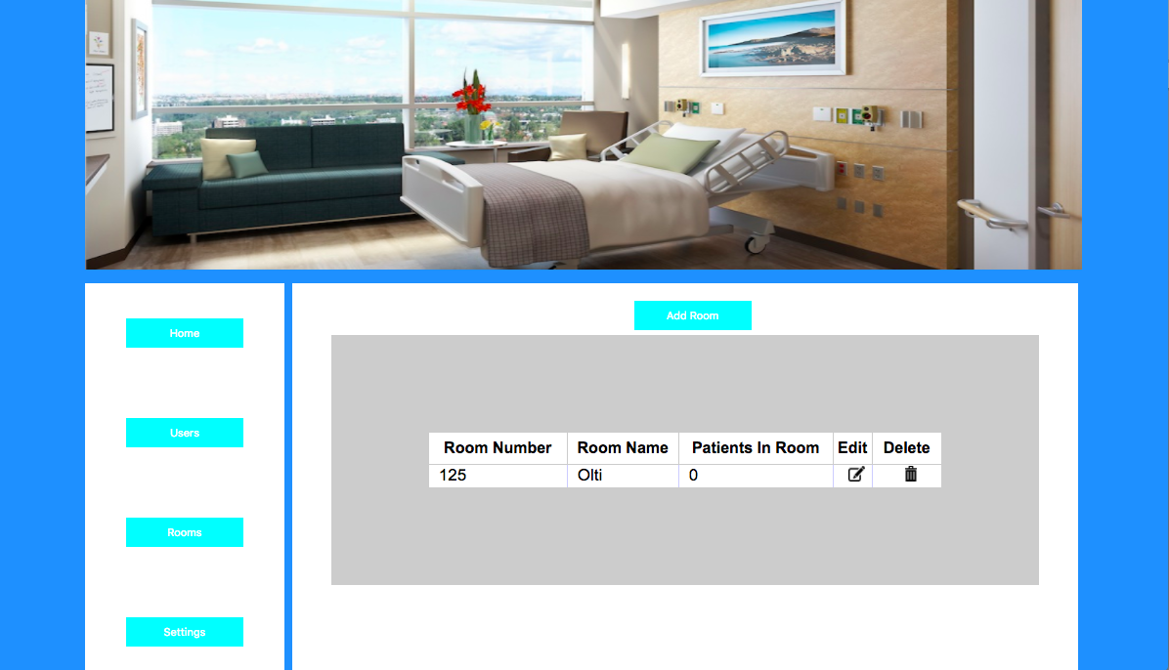

The total number of users is displayed in the Administrator dashboard.

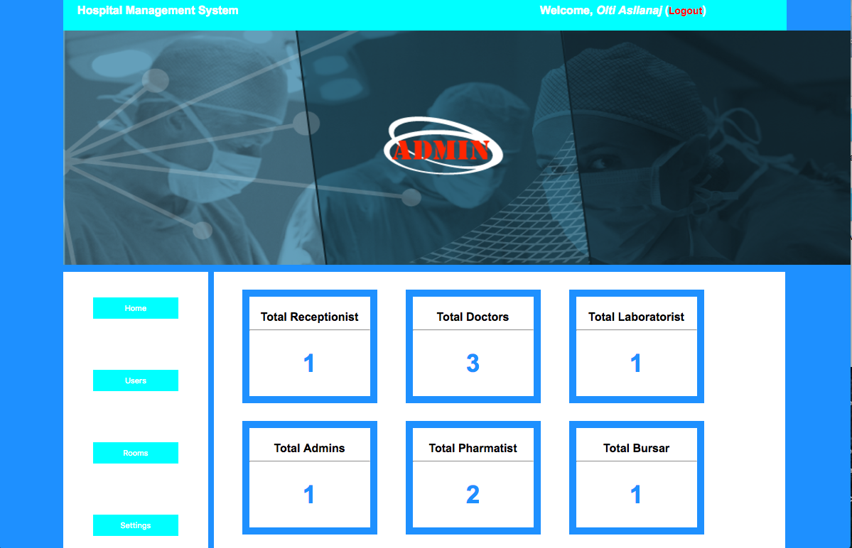

**RECEPTIONIST DASHBOARD && FUNCTIONS**

The receptionist logs into the system using the username and password created by the Administrator. In the receptionist dashboard you can choose Patients to Add patients and Settings to update the receptionist information. This is the receptionist dashboard:

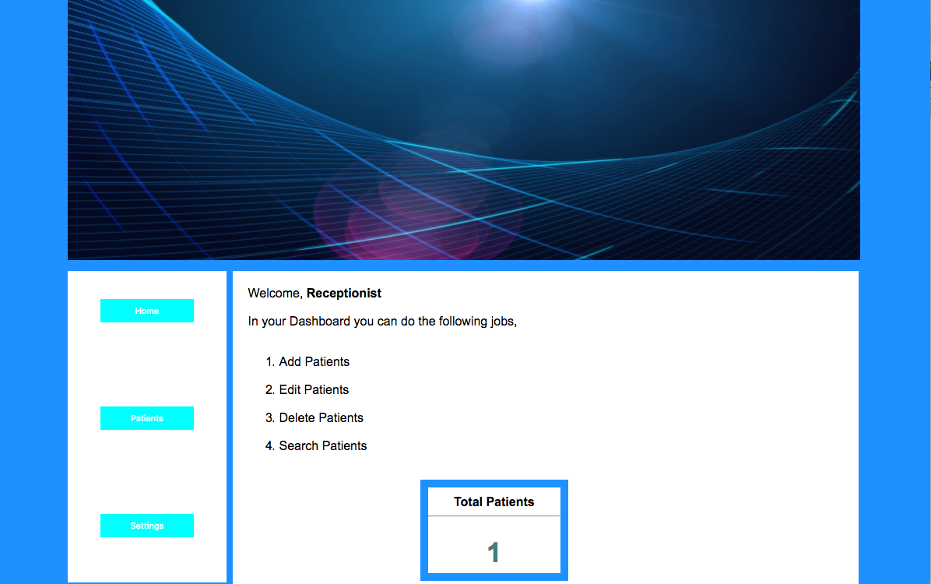

The receptionist can add patient’s details by using the form:

So you need to enter these details for the patients: first name, last name, email, phone number, address, gender, blood group and birth year and press ADD.

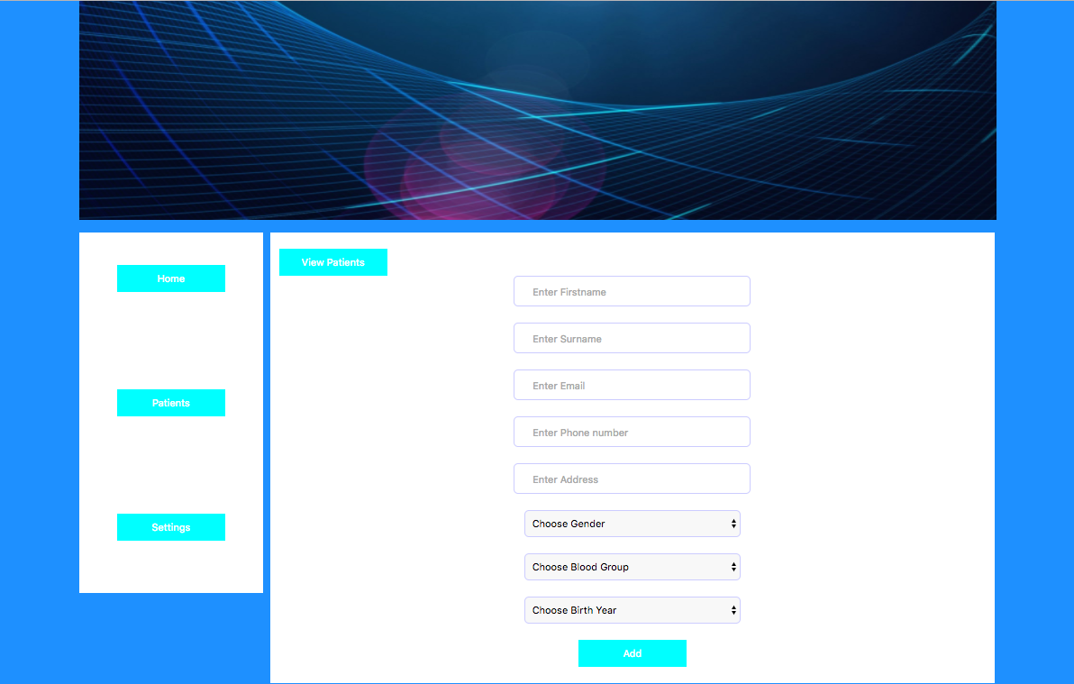

After adding the patient to the system we can press view and we can send the patient to the relevant doctor.

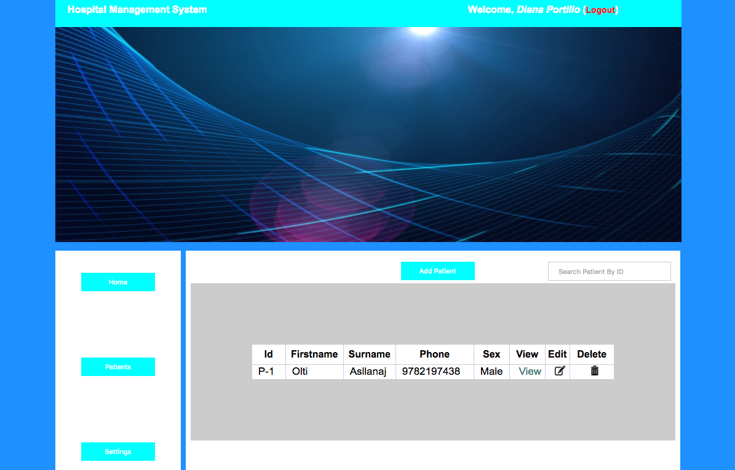

After pressing view we can see all the patient information and choose the doctor for the patient. For example: normal doctor, eye doctor, woman doctor and you can create other doctors from the admin dashboard.

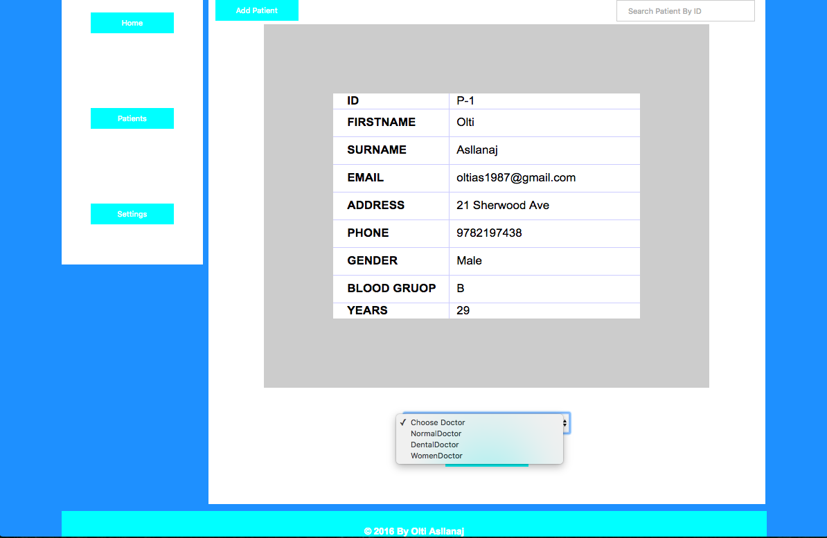

The receptionist can update his/her information after logging for the first time. He/she can update first name, last name by entering the password and pressing the update button.

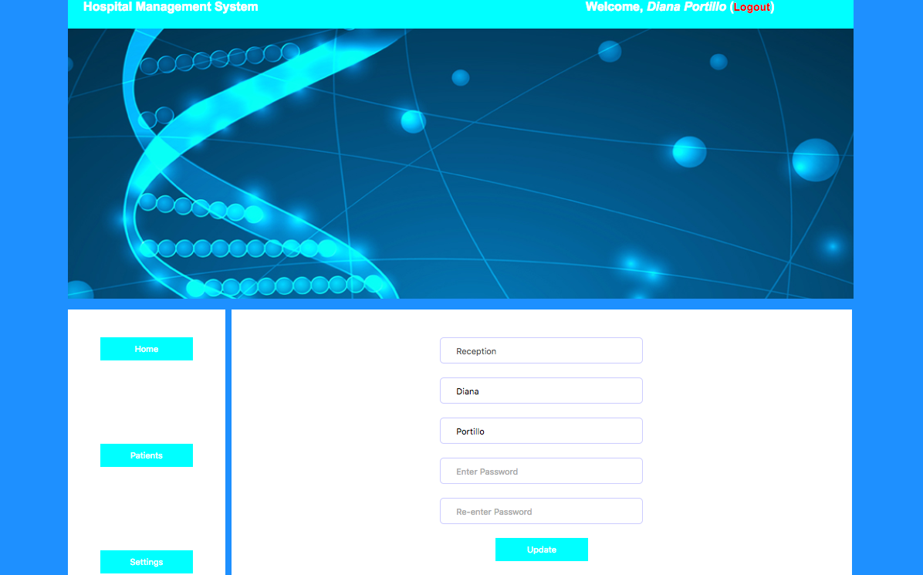

**DOCTOR DASHBOARD && FUNCTIONS**

The doctor dashboard has more functions. This is the doctor dashboard:

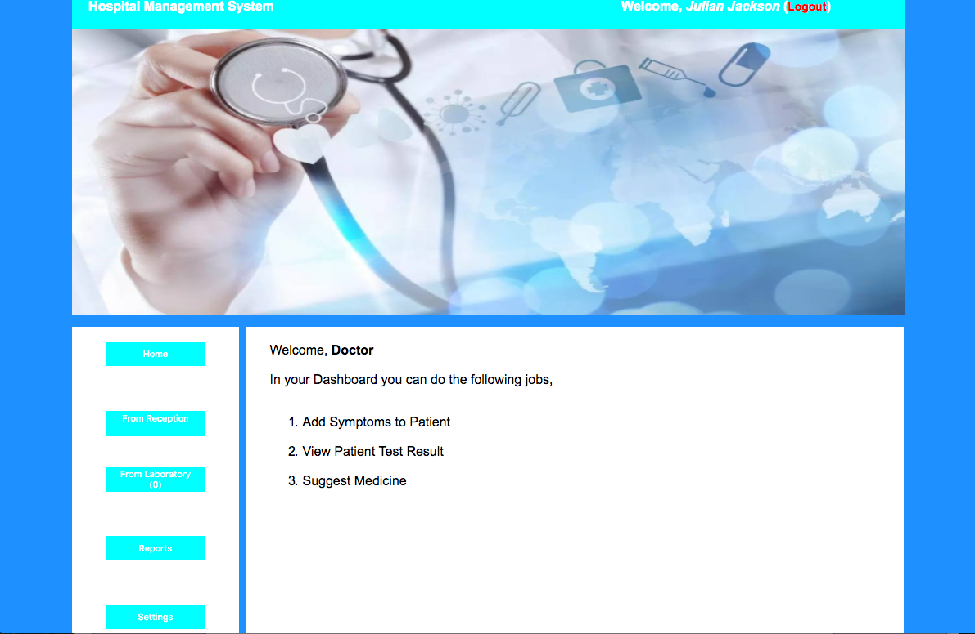

The patient information is assigned now to the doctor from the receptionist. So to see the patient information we need to press From Receptionist and we can add symptoms of the patient by pressing ADD.

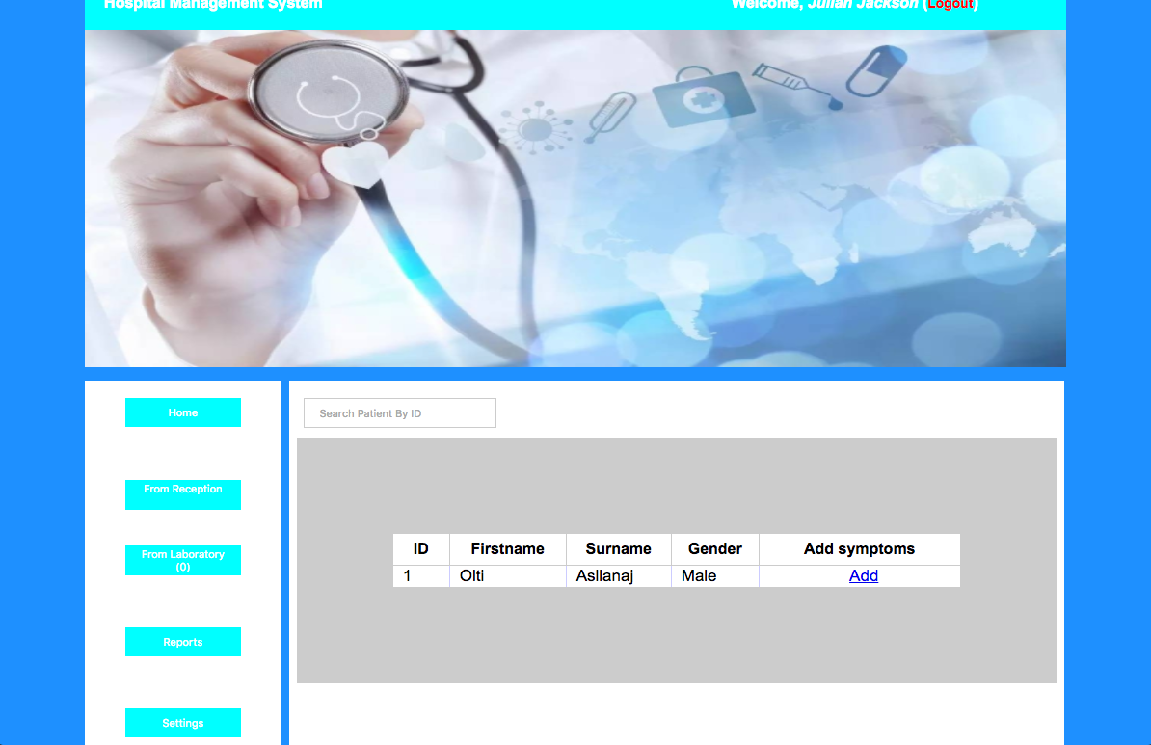

After you press ADD you can see the patient name and enter the symptoms and test suggestions. After that we press Send To Lab for the necessary tests! For example:

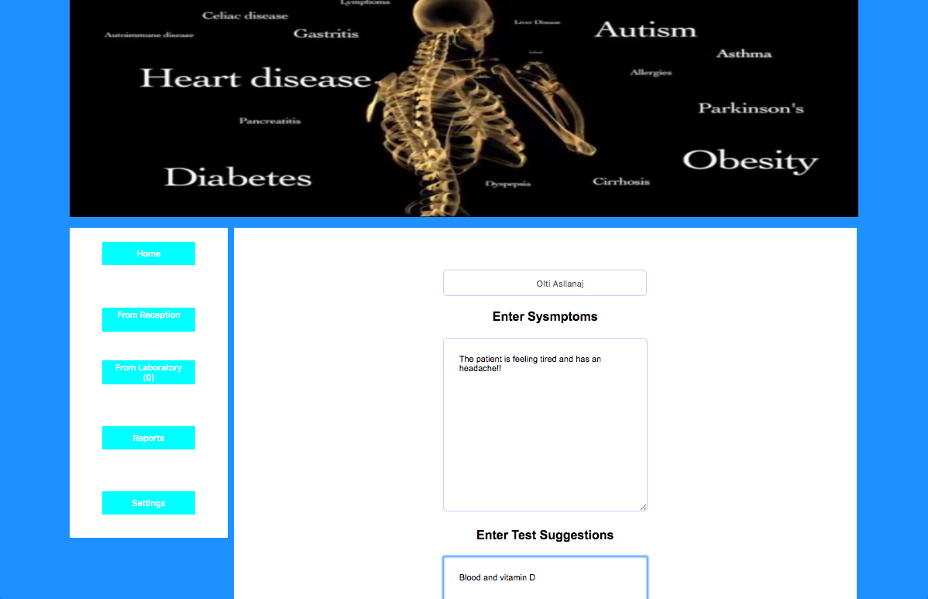



After send those to the laboratory the doctor needs to wait for the results. After the results are here we need to press From Laboratory to see the test results. After we press From Laboratory we can see the patient information and press view to check the blood results and give to the patient the Medicine. After, we send the information to the Pharmacy where the patient can get the medicine and go home. After the doctor has the possibility to find the every report for every patient by pressing Reports.

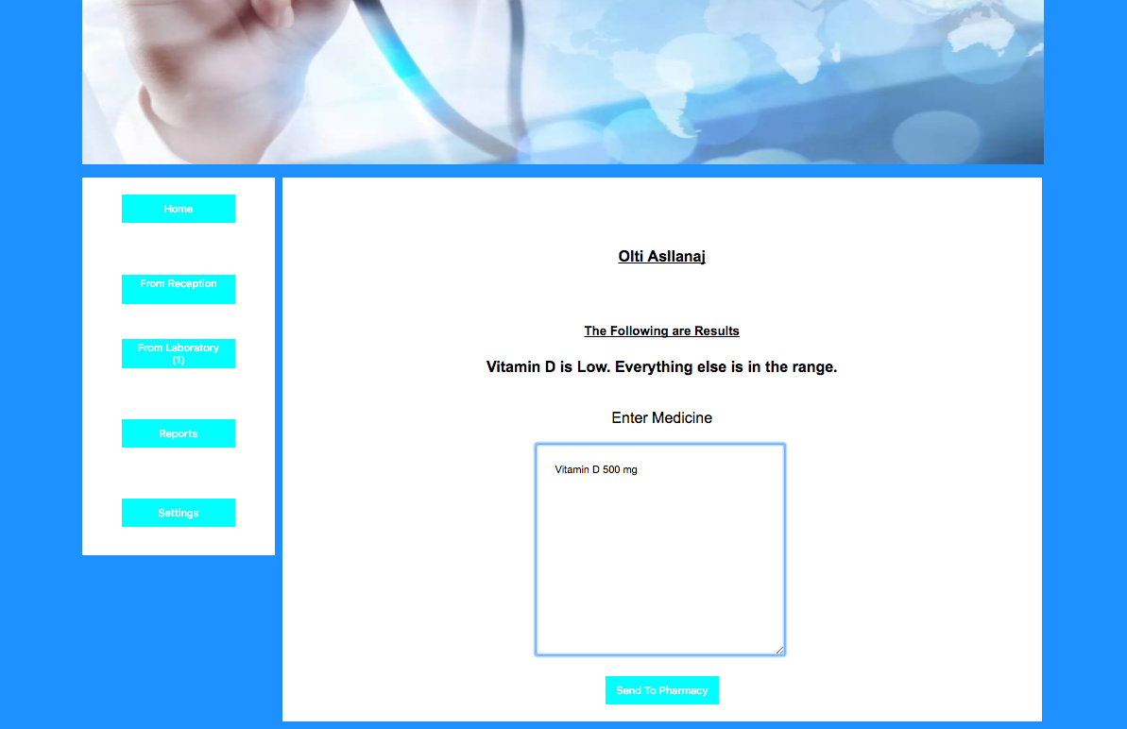

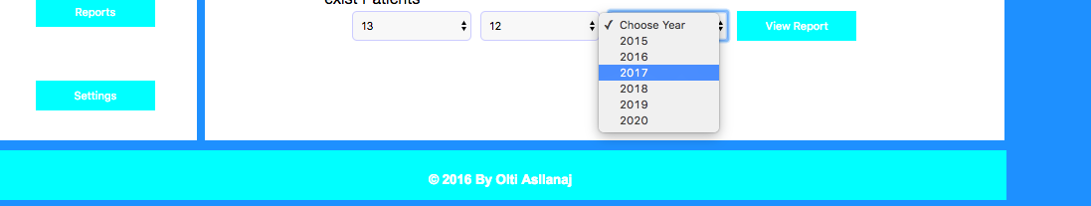

The last one is Setting when the doctor that is using the system for the first time can update his/her information.

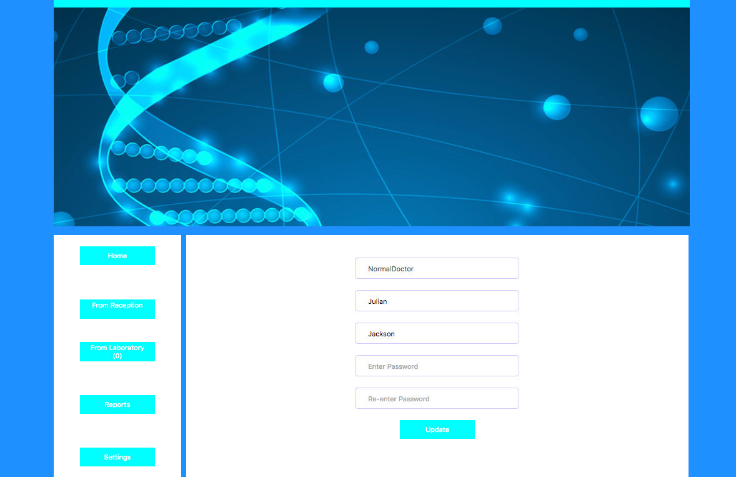

**LABORATORY DASHBOARD && FUNCTIONS**

The laboratory can view test suggestions from the doctor and patient information. Also can add the price for the different test and enter test results and send those to the doctor. Also search patients.

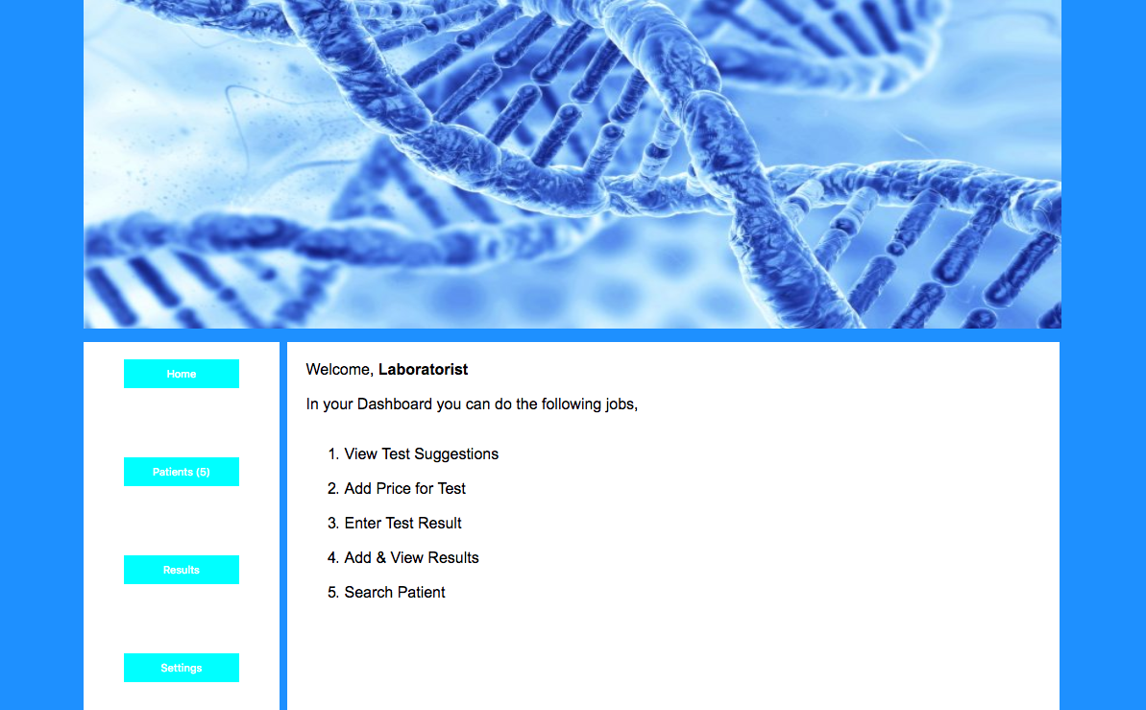

If we press Patient button we are going to see the patient information and after we press view we can do the test and send the test results to the doctor.

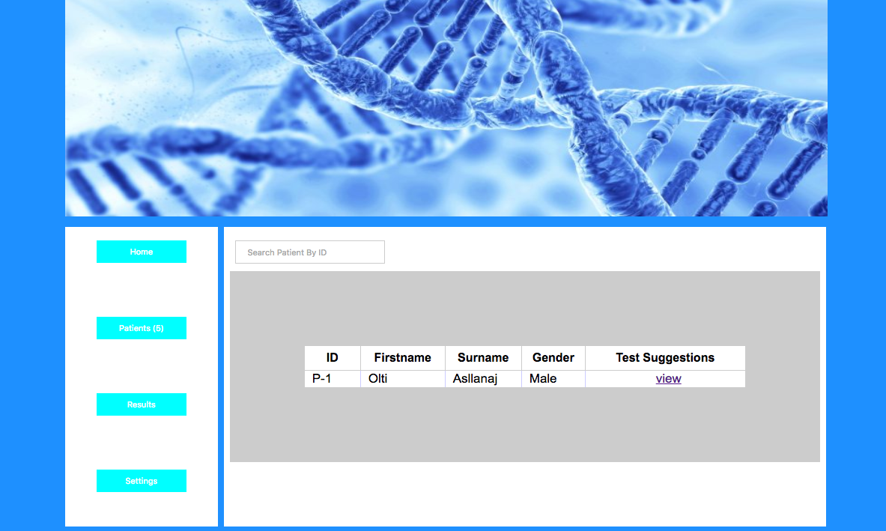

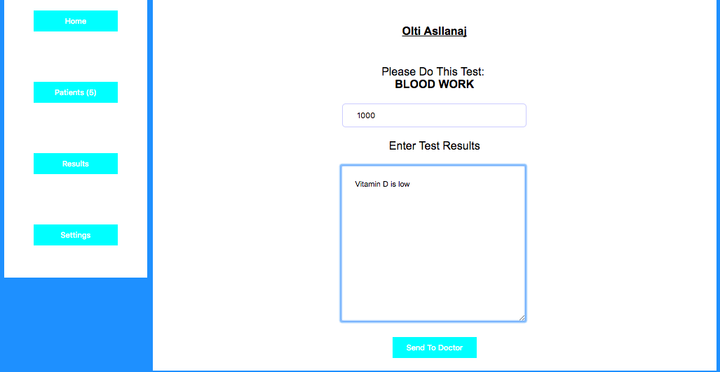

In the result table your going to see different patients with different test results.

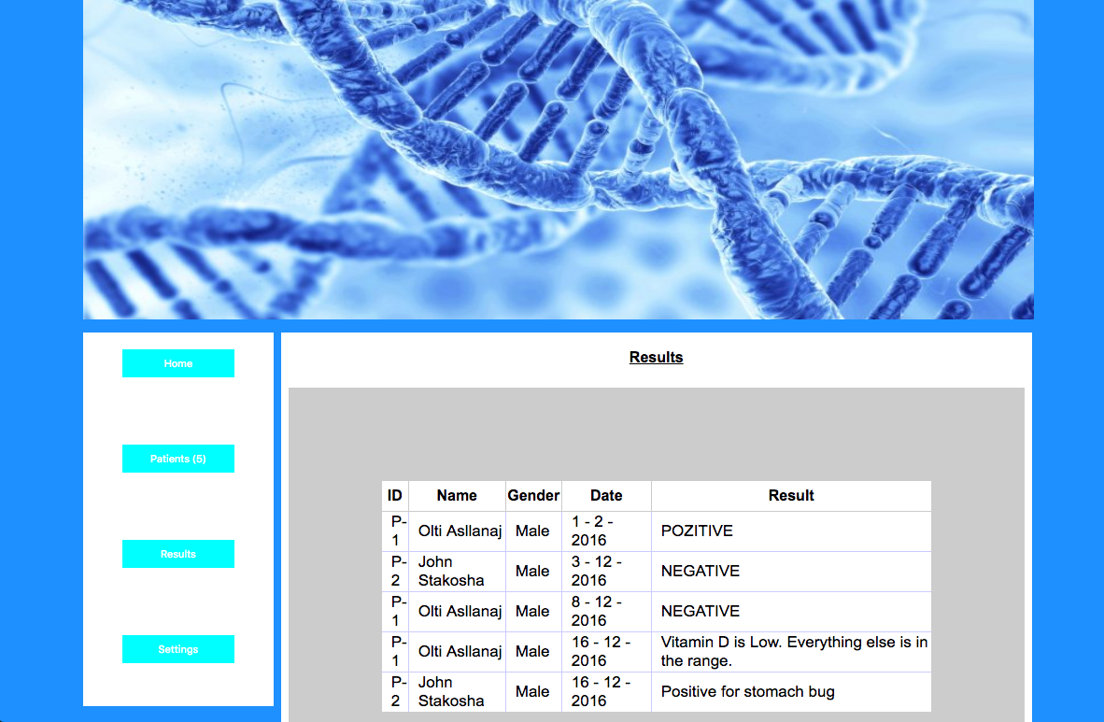

The doctor dashboard has settings where the doctor that is new can update his/her name and last name.

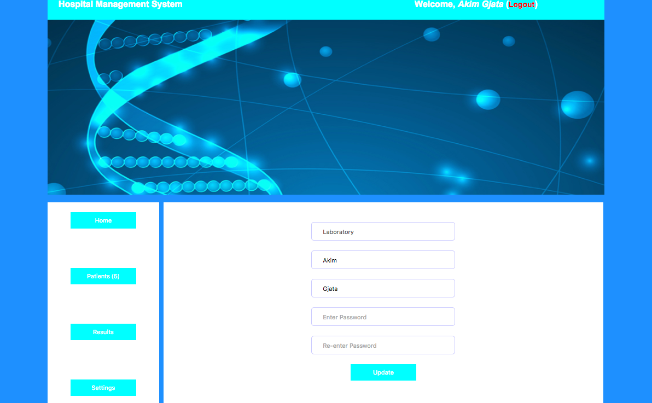

**PHARMACY DASHBOARD AND FUNCTIONS**

The pharmacy gets the prescription from the doctor. The pharmacy can enter the price of the Medicine. The pharmacist can add different medicines in the stock, edit and deleted. The Pharmacy dashboard:

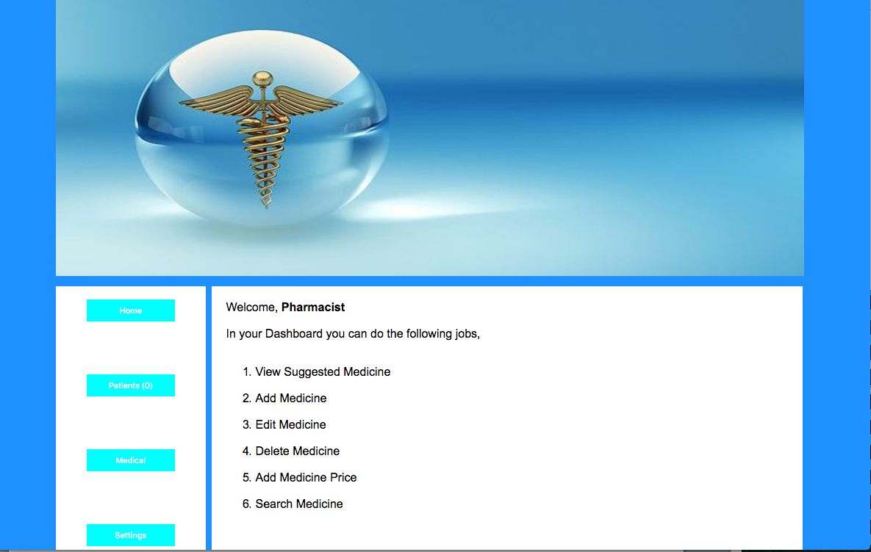

In the Patients dashboard you can see the information of the patient and after pressing view you can see the doctor prescription of the medicine. Then you can enter the price of the medicine and the patient takes the medicine and pays to the bursar.

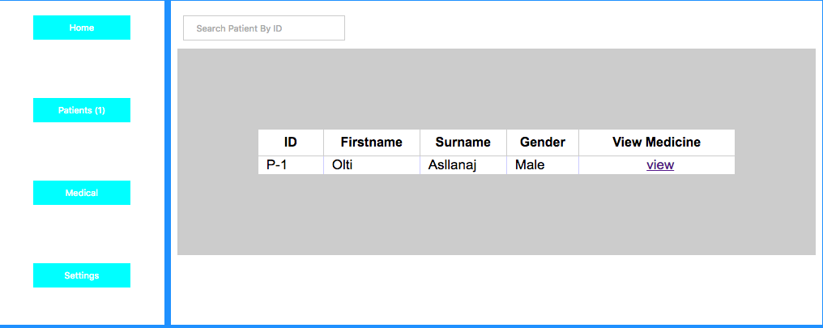

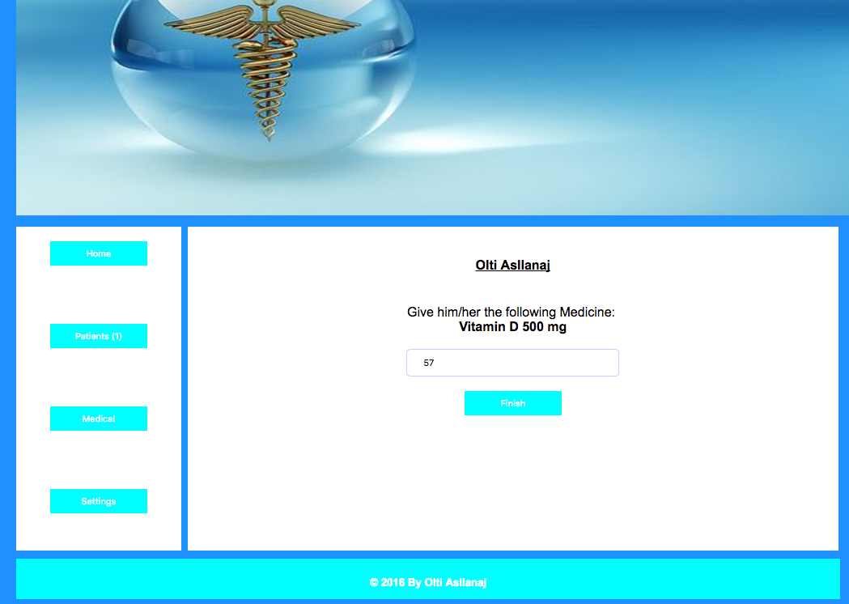

In the medical dashboard the pharmacist can add, update and delete medicines. He/she can store those in the stock or update and delete from the stock.

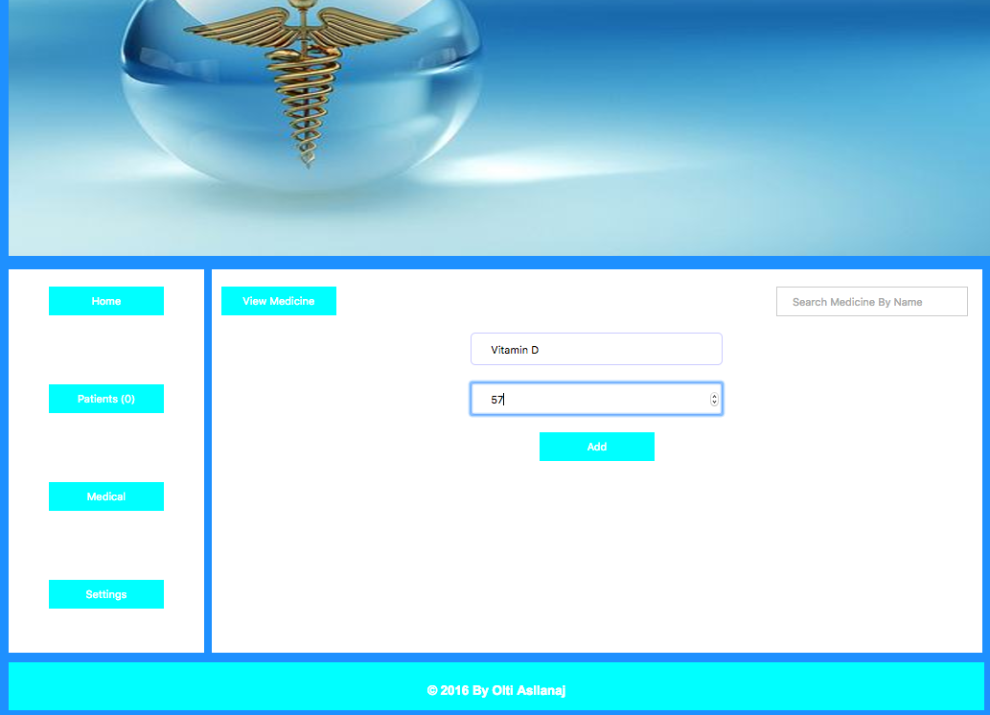

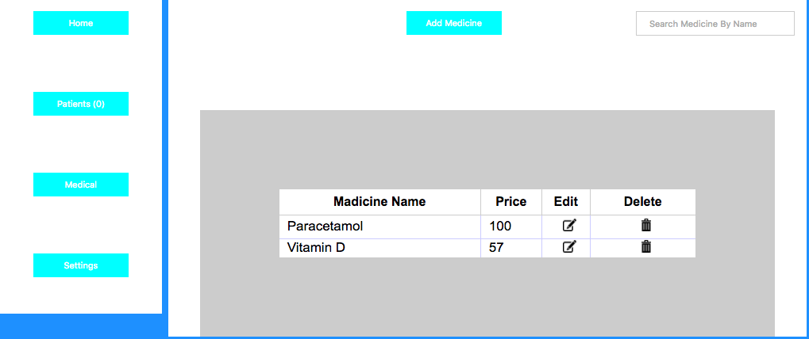

In the Settings dashboard the pharmacist that is accessing the system for the first time can update his information.

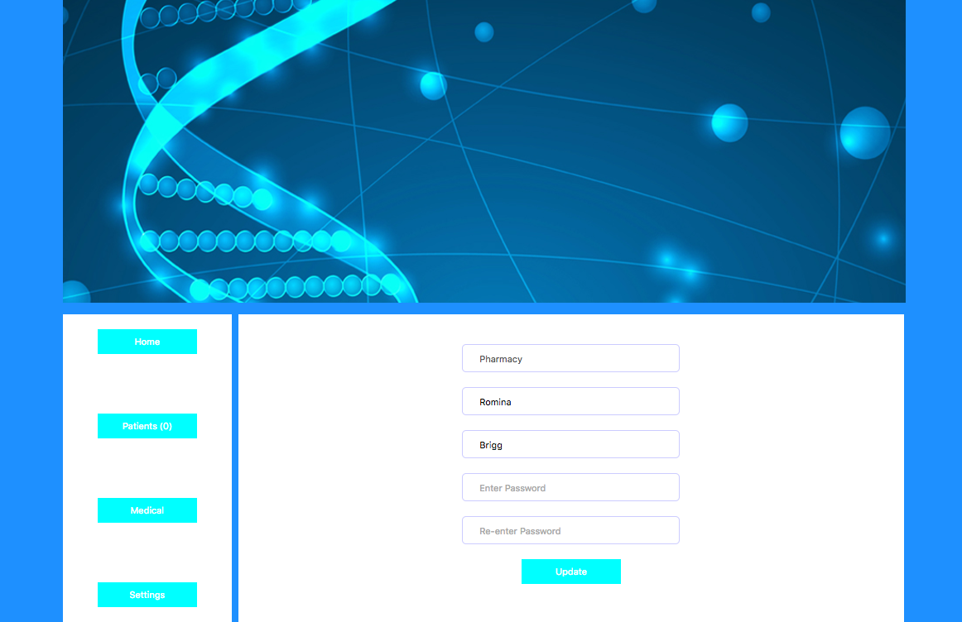

**BURSAR DASHBOARD AND FUNCTIONS**

In the bursar dashboard the bursar or accountant can see the financial report of the year and he/she can search for a specific report. The Bursar is Silva Kaziu. This is the Bursar dashboard:

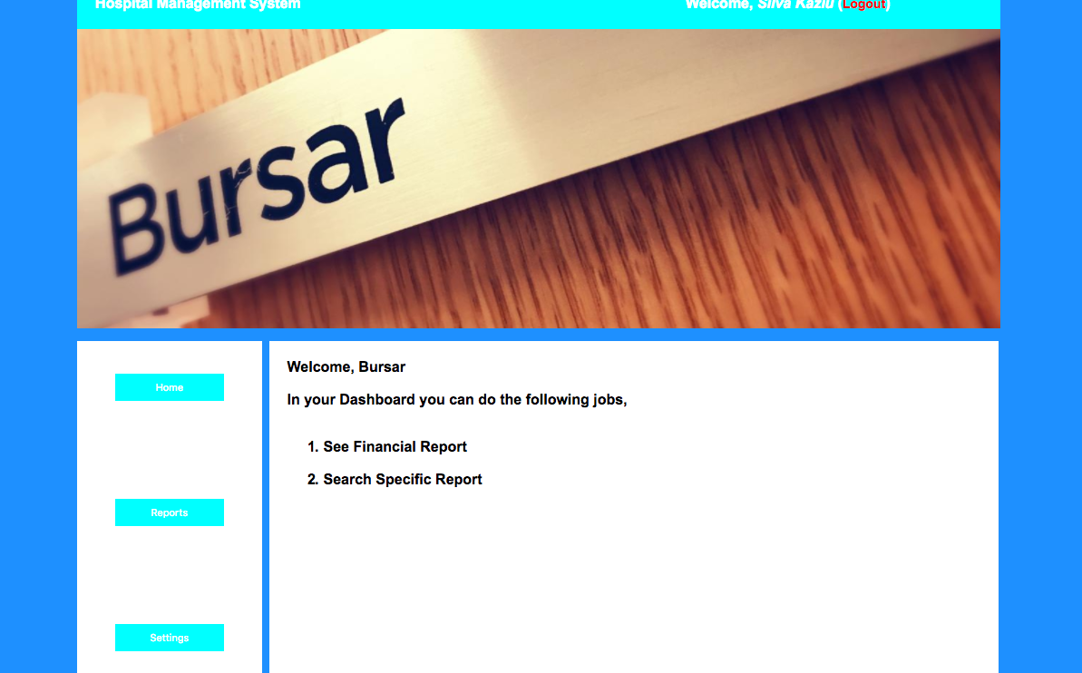

In the report dashboard we can see the financial report and check for specific reports. For example:

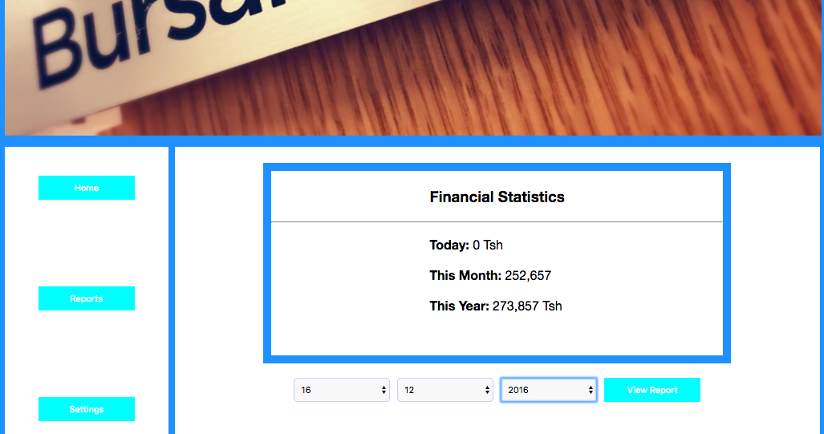

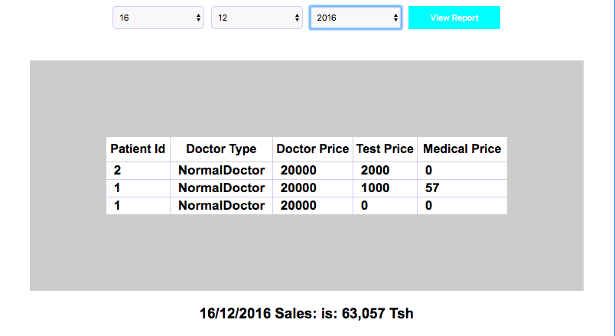

**Conclusion**

This project was very useful and helped me to understand more how to work with front-end and back-end. This project was great not just because was fun but at the same time I learned two different programming languages SQL and PHP + HTML + CSS. I will continue to work on this project during the break!! I will add this project to my resume for my internship interviews. Great project.

Thank you,

Olti Asllanaj